Marine Biology Monterey CA Winterim Jan. 2022
Students if you are interested in the Marine Biology Class for Jan. 2022 Winterim you will need to sign an interest form with Mrs. Hizer by Fri. April 16th.

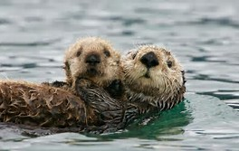
The Marine Biology Winterim Class will study saltwater plants and animals that live in our oceans. The class will study a wide range of topics from the behavior, physiology and ecology of specific groups of organisms. Organisms include everything from the largest whales to the smallest plankton. Each student will study and complete a research active lab on a marine organism. This will be done in the classroom at LHS and on the ocean at Monterey Bay, CA.
Class will include:
- Fundraising in Summer (Car Washes, Price Chopper Coupon Sales,???)
- Fundraising in Fall (Fun Run, Kid’s Night Out, Musical Concessions, chili dinners, Friday Morning Doughnuts and Coffee, T-shirt Sponsors)
- Jan. classroom studies at LHS--Marine Biology Study and Research Lab Activity
- Jan. Trip to Monterey CA for 6-7 day hands-on study trip
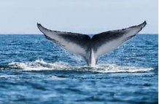
Activities include:
  - Whale watching with biologist and naturalist
  - Asilamor Park beach scavenger walk
  - Point Lobos exploration and tide pooling
  - Famous Monterey Aquarium
  - Fort Ord—sand dunes and environmental issues
  - Historic Cannery row and shopping
  - Kayaking on the bay--guided tour (otters, seals, Kelp beds)
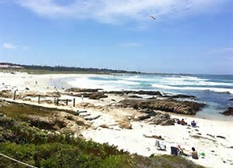
  - Explore Carmel Beach
  - Ano Nuevo Park guided tour walk for Elephant seals
  - Moss landing pontoon wildlife adventure
  - 17 mile drive
- Cost per student is $1,300. This includes all activities, flight, and food. Deposit of $500 is due on Oct. 1st. The remaining money will be fundraised.

